Abstract—Cardiac oscillation correlated to decrements in the amplitude of the photoplethysmography signal (DAP) were analyzed during normal and apneic sleep. 268 ECG excerpts from 21 patients were analyzed. Segments were separated in 5 groups G1-G5 depending on SaO₂ and respiratory behavior during DAP event. Smooth pseudo Wigner-Ville distribution was used for spectral parameters. Three windows were selected: before DAP, during the DAP and after DAP. Results show an increase on sympathetic activity during DAP events. This increase is greater when DAP events are associated to respiratory or SaO₂ variations. However this spectral parameters did not show stadisticaly significant differences when the DAP were associated with apnea. This situation could be related to the fact that repetitive obstructive episodes could have a sustained sympathetical tone, avoiding to visualize differences between pre and during DAP. In conclusion, during DAP events the HRV always present changes in the oscillatory pattern which suggests that the regulatory mechanisms are the same but the intensity of the changes in HRV depends on the physiologic condition.
Relationship among Envelope Fluctuations in PPG, HRV and apnea
M. O. Mendez 1, E. Gil 2, J. M. Vergara 3, S. Cerutti 1, A. M. Bianchi 1, P. Laguna 2

INTRODUCTION
Obstructive Sleep Apnea Syndrome (OSAS) is one of the most common sleep pathologies with high prevalence in the general population. OSAS prevalence could arrive at percentage as high as 4% in men, 2% in women and 3% in children. Generally, sleep apnea is undiagnosed since pain symptoms do not appear and patients not attain for medical aid. The most common sleep apnea indicators are daily sleepiness, irritability, tiredness, low concentration and impaired learning. Those factors generally produce more serious consequences such as social problems and job and traffic accidents. In addition, OSAS produces hyperactivity and low capacity to attend mental tasks during childhood [1]. Severe OSAS generates diurnal hypertension and much more cardiovascular health implications that can cause the decease [2].
OSAS consists in an interruption of the airflow to the lungs produced by an upper airways occlusion. When the interruption occurs, blood oxygen goes down across the time and mechanical respiratory efforts are intensified in order to reopen upper airways. If these efforts are not sufficient and hypercapnia level is dangerous, an arousal is generated to reactive all the peripheral systems and the respiration is restored. This episode could occur hundreds of times in a single night producing serious health implications [3]. The open-close cycle in the upper airways produces a regular oscillatory state of pheripheral systems such as cardiac and vascular. For instance, heart rate decrements during apnea and increases during restore breathing. While vascular system presents vasoconstriction during apnea and vasodilatation after apnea.
On the other hand, some studies have shown that photopletysmography signal (PPG) has information about the vascular mechanism. Particularly during apnea, vasocontriction occurs and it is reflected in the PPG signal by a decrease in the fluctuation of the signal amplitude (DAP). However, not all DAP events are related to pathologic respiration (apnea) and it seems that photoplestimography signal is sensible to other events that generate vascular activations [4]. In order to better understand the oscillatory and control mechanisms inside the cardiovascular regulation during sleep, we consider the analysis of DAP episodes together with heart rate oscillations (HRV).
HRV is an electro-physiological signal very broadly studied for apnea diagnosis. HRV presents fluctuations related to the Autonomic Nervous System (ANS). HRV exhibits frequency components from 0 to 0.5 Hz, which are associated to the autonomic nervous system branches. The frequency components between 0.15 and 0.5 Hz represent the vagal tone, frequencies in this band are known as high frequency components (HF). Frequencies from 0.04 to 0.15 Hz manifest the activation of both parasympathetic and sympathetic nervous and these are labeled low frequency components (LF). Finally, frequencies between 0.0033 and 0.04 give information of the slow processes such as thermoregulation. Because of the participation of parasympathetic and sympathetic nervous in the low frequency component is uncertain, the ratio between LF and HF is defined as the sympatho-vagal balance [5].
The aim of this study is to analyze the interrelation of cardiac (HRV) and vascular (DAP) regulatory system in normal and pathologic respiration during sleep with the objetive of evaluate their potential to distinguish DAP episodes associated to apnea from those that are not.

Methods
Protocol.
Whole night polysomnography recordings from 21 children were used in this study. Age of the children range in 4.47 +/- 2.04 years. Children were referred to the hospital for suspected sleep disorders breathing. EEG, chin electromyogram, ECG, eye movements, airflow and chest and abdominal respiratory efforts were recorded by a digital polygraph (BITMED EGP800), according to the standard procedure defined by American Thoracic Society [6]. PPG and arterial oxygen saturation (SaO₂) were measured continuously using a pulse oximeter (COSMO ETCO2/SpO2 Monitor Novametrix, Medical Systems). All signals were stored with a sample rate of 100 Hz, except ECG signals that were sampled at 500 Hz. OSAS evaluation from PSG data was scored by expert personnel using the standard procedures and criteria [7]. Ten children were diagnosed with OSA and eleven were diagnosed as normal. All recordings were recorded and scored at the Miguel Servet Children ‘s Hospital, Zaragoza, Spain.
TABLE I
Number of DAP events in each group
 | DAP Group
Diagnosis | G1 | G2 | G3 | G4 | G5 | Total
normal | 4 | 32 | 5 | 76 | 31 | 148
apnea | 44 | 21 | 33 | 11 | 11 | 120
Total | 48 | 53 | 38 | 87 | 42 | 268

Photoplethysmography DAP detection.
During sleep apnea or arousal events, sympathetic tone increases generating arterial vasoconstriction. This transient sympathetic activations are reflected as amplitude reduction in the PPG signal (DAP) [8]. In order to identify DAP events, we applied an algorithm based on detecting the envelope attenuations of the PPG [9]. PPG signal x_{p}(n) is detrended (x_{pDC}(n)) by removing the mean value obtained with a moving average filter. Artifacts were detected in x_{pDC}(n) by an algorithm based on Hjorth parameters and the artifacted segments were rejected. The envelope x_{E}(n) of x_{p}(n) is obtained by applied the following equation:

$x_{E}(n)=\sqrt{\frac{1}{N_{p}}\sum_{k=n−(N_{p}−1)}^{n}{x_{\text{pDC}}^{2}(k)}}$ (1)
Where N_{p} is the number os samples in two cardiac cycles. A DAP event is identified at time n when x_{E}(n) is lower than a pre-defined adaptive threshold having a minimum duration.

Group stratification criteria for the DAP events.
Medical diagnosis consisted in dividing the whole database in normal and pathologic subjects. DAP events for each recording were detected with the procedure described in photoplethysmography section. Segments from ECG, PPG, SaO₂ and EEG centered at the DAP event onset and lasting 5 minutes were extracted. DAP events were separated in five groups based on the gold standard criterion to define sleep apneas [7]. Group 1: A DAP event is classified into this group if SaO₂ decreases at least 3% and there is no a clear reduction in airflow signal. Group 2: single DAP event belongs to this group if airflow decreases at least 50% respect to the baseline at least for 5 seconds. Group 3: if the airflow reduces more than 50% of the base line and it is accompanied by a reduction in SaO₂ of at least 3% the DAP event is classified inside to this set. Group 4: If a DAP event is not correlated to neither airflow reduction nor SaO₂ decrement, then the event belongs to this group. Finally, Group 5 is formed by DAP events that are not related to apneas or SaO₂ decrements but a change in respiration occurs. A total of 268 DAP events coming from 10 apneic and 11 normal subject were extracted. Table 1 shows a summary of the DAP events of each group.

Time-frequency analysis.
In this study, Time-Frequency analysis has been used to assess the time evolution of the autonomic control mechanism. Time-Frequency analysis presents interesting mathematical and visual features to analyze short time-varying series with high time-frequency resolution. Time-Frequency analysis is organized in different classes. The approaches of a specific class present common characteristics. In this study, it was selected an approach which belongs to the Cohen’s class time-frequency distributions. This class obeys the property of time and frequency shift invariant [10]. Cohen’s class is defined by the next equation:

$C_{x}(t,f)=\iint{φ(t−t\text{',}τ)x∗\left(t'−\frac{τ}{2}\right)x\left(t'+\frac{τ}{2}\right)e^{−j2πfτ}\text{dt}'dτ}$ (2)
Where $φ(θ,τ)$ is a function labeled kernel and x(t) is the signal to be analyzed. The kernel properties define the distribution properties. Then a specific kernel defines univocally a distribution. The kernel is a bi-dimensions filter, which purpose is to eliminate noising energy components generated by the quadratic nature of the distribution. Those spurious components are known as cross-terms and disturb the energy signal interpretation in the time-frequency plane. In this study, Smooth Pseudo Wigner-Ville Distribution (SPWVD) has been used. This distribution is characterized by independent smoothing functions in time and in frequency, originated by $γ(t)$ and η(τ/2) η*(-τ/2) windows respectively.

$$ϕ(t,τ)=γ(t)η\left(\frac{τ}{2}\right)η^{}\left(−\frac{τ}{2}\right)$$
The SPWVD parameters were chosen as follows: for smooth time, a Hamming window of 0.042 seconds was selected. While for smooth frequency, a Hamming window of 0.258 seconds was taken.

HRV analysis.
Inverse interval function (IIF) [11] denoting the heart rate in beats/s time series were extracted from the ECG segments by an automatic algorithm based on wavelets ECG delineator (Class separation criteria) [12]. IIF sequences were re-sampled at 2 Hz by cubic spline interpolation. Resulting time series were detrended by subtracting the mean value. Subsequently, analytic signals from each segment were obtained by applied Hilbert transform to the IIF sequences. After that, SPWVD was used to decompose the analytic IIF sequences in their different frequencies at each time. Then, the time evolution of the normalized classical heart rate variability indexes was evaluated: total power, from 0.0033 to 0.5 Hz (PT); very low frequency power, from 0.005 to 0.04 Hz (VLF); low frequency power, from 0.04 to 0.15 Hz (LF); high frequency power, from 0.15 to 0.5 Hz (HF); and low to high frequency ratio (LF/HF).

Statistical analysis.
In order to quantify the evolution of autonomic variations when a DAP event is associated or not associated to airflow decrements, SaO₂ reductions or nothing, three time windows were selected in specific time slots. Fig. 1 shows an example of the IIF sequences when DAP is related or not related to an apneic episode, as well as strategic time windows in relation to DAP event. Time at 0 s represents the DAP onset. The time windows are placed as follows: 1) Baseline window is located 15 s previous to the DAP event onset with a duration of five s. 2) Episode window is found two seconds before the DAP onset and lasting five seconds 3) Recovery window is located 15 seconds after DAP onset and lasting five seconds. Mean absolute values in the time windows were computed for IIF sequences, VLF, HF, LF and LF/HF as well as for the normalized version with respect to the total power of the spectral parameters. Kruskal-Wallis non parametric statistic approach was performed to compare the time variation across windows of temporal and spectral parameters of the HRV. Tukey HDS post-hoc analysis was applied to evaluate significant statistic differences between groups (p < 0.05).
Fig. 1 IIF mean ± S.D. for apneic (G1+G2+G3) and non-apneic (G4+G5) events. Analysis windows (1 baseline, 2 episode, 3 recovery). Dashed line at reference time indicate DAP onset.

RESULTS

From the top to the bottom, Fig. 2 shows means and standard error of IIF, HF, LF and LF/HF for each group. Spectral parameters are normalized respect to total power. G1, G2, G3 and G5 present increments in the iif signal during event window, this increments result being statistical different respect to both baseline and recovery windows. LF elicits also increments during the event window in G1, G2, G4 and G5 that are only significant from the recovery window. Event window shows reduction in the HF for all groups, however significances are found in G1, G2 and G5. LF/HF also presents significant differences in those groups, but with an increment in the event window.
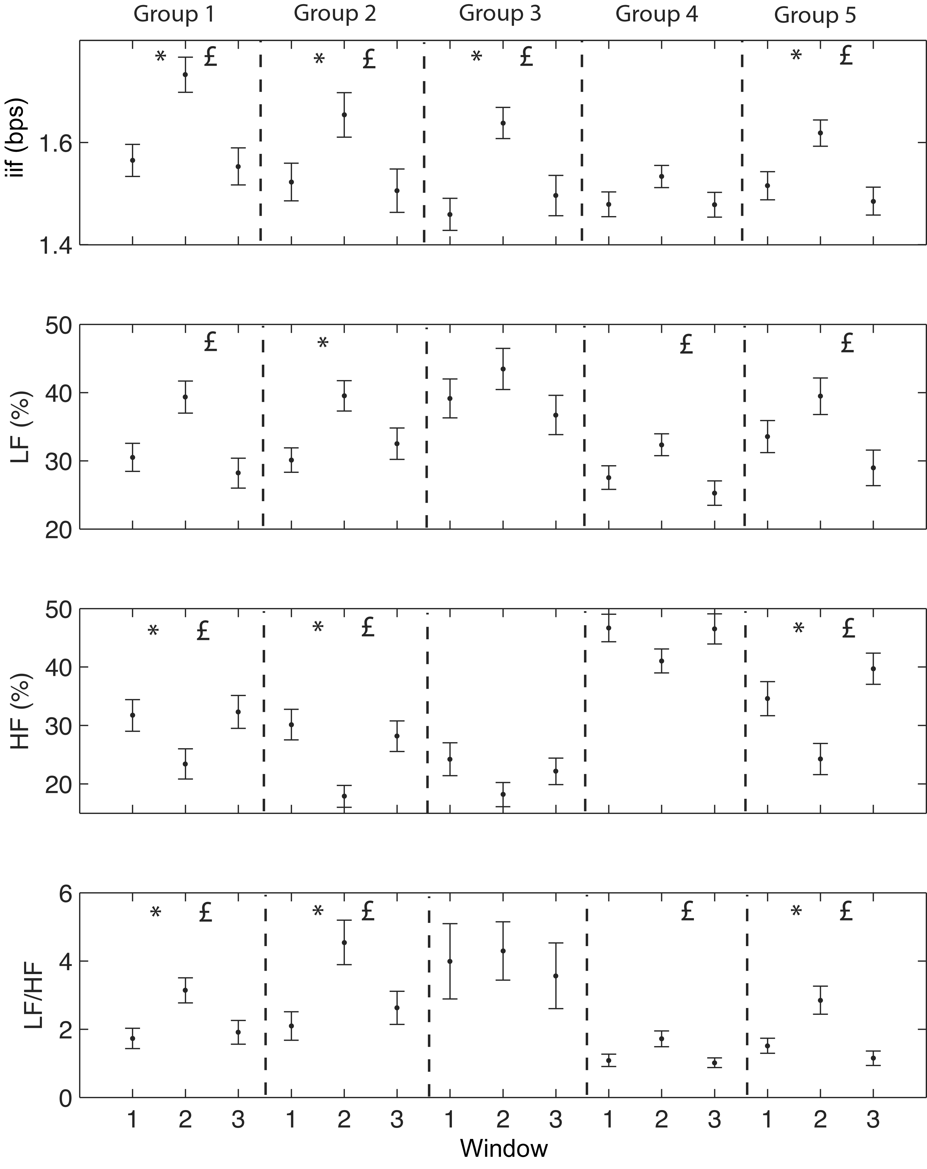

Fig. 2 IIF mean ± SE and spectral indexes obtained by smooth pseudo Wigner-Ville distribution. Window refers to the temporal windows analyzed during DAP (1 baseline, 2 episode, 3 recovery). From the top to the bottom, heart rate, low frequency (LF), high frequency (HF) and low to high frequency ratio (LF/HF) of heart rate. All the spectral parameters were normalized respect to the total power at each time. * refers to p<0.05 between windows 1 and 2 and £ is p < 0.05 between windows 2 and 3.

Discussion
Analysis of the autonomic control during decrements in the photopletysmography signal (DAP) in children was presented. Our main findings were: DAP event associated only to SaO₂ decrease also produce strong variation in both heart rate and spectral indexes. When DAP events are not associated to either respiratory events or SaO₂ decrements, heart rate variability remains without alterations and its spectral power is more shifted to the high frequency component.
Photopletysmography signal carries information related to the cardiovascular function as well as blood gases concentration. This signal presents interesting characteristics that can be used to detect apneic episodes. However, due to its high sensibility, misdetections could be produced and as consequence an overestimation of the apneic episodes. Generally, in most of the studies PPG has been directly related with the cardiac function (R-wave-gated photoplethysmography (RWPP)) given as results a measure of the Pulse Transition Time (PTT). PTT gives a quantitative measure of the time that a pulse wave needs for passing from one arterial to another one. RWPP is evaluated as the time interval between the ECG R peak and the start of the corresponding PPG wave. OSA produces a PTT decrement because the sympathetic activation produces heart rate increment, higher stroke volume and vasoconstriction, which in turn, generate pulse wave acceleration. However, some other physiological events such as slow paced breathing and deep inspiratory gasp [4] induce also variation in the PTT that could be confused with activations. In addition, this integration looses important information that could be obtained from the spectral parameters of heart rate. Dynamic of heart rate and spectral parameters offer, time and frequency information, that could help to discriminate between small cardiovascular variation and more severe ones, as it is the case when an apneic episode occurs. However, when only HRV spectral parameters are used to detect apnea, sensibility lost occurs since there is not a pre-screening of the potential apneic events as the DAP detection provides, improving the sensitivity and specificity values.
Heart rate control oscillates in a specific range of frequencies. These frequencies characterize the autonomic nervous control that are activated or inhibit as a results of feedback mechanisms. These variations, in the autonomic control, are observed indirectly by the time sequence formed beat to beat (RR sequence). Under constant condition such as rest, autonomic control is very regular and RR sequence shows a stationary pattern. This situation allows the application of techniques such as Fourier transform to obtain the spectral components of the time series. However, during conditions of rapid changes such as sit to stand and sleep apnea, autonomic control adapts speedily to satisfy the systems requirements, then the RR sequence shows non-stationary periods. During such conditions, most sophisticated techniques of signal processing are required to analysis the time evolution the autonomic control mechanism. Different approaches have been developed to attend this problem. Time-Frequency, Time-Varying and Time-Scale analysis are some of the most powerful tools.
Smooth Pseudo Wigner-Ville Distribution allowed us to evaluated the spectral component of the heart rate variability with high time and frequency resolution. However other techniques as wavelet and filter banks satisfy the characteristic necessary to obtain the spectral parameters of heart rate with high time frequency resolution. In addition, other distribution such as Born-Jordan and Choi-Williams distribution offer characteristic for this kind of analysis.
This methodology could be improved if the spectral parameters of hear rate are extracted from the PPG, in this way, only acquisition of one signal could be enough for analyzing sleep apnea episodes. Since PPG signal is a very simple and economic measurement of easy acquisition, PPG presents high potentiality for home apnea monitoring, reducing cost of wearable devices and complicated technology for the analysis. Additionally, processing of PPG signals could be implemented in real-time and with very low computation cost.

Conclusion
During DAP events the HRV always present changes in the oscillatory pattern showing an increase in sympathetic activity which suggests that the regulatory mechanisms are the same. However, these oscillations of the heart rate are greater during DAP events associated with apnea than during DAP events not related to apnea. Application of DAP events as detector of apneas plus HRV oscillations, as features to decide if the DAP episode is an apnea or not, could be an interesting combination in order to obtain an automatic apnea screener.
Acknowledgment
This study has been supported by CIBER-BNN Spain and by TEC2004-05263-c02-02 from MCyT and FEDER Spain.
.
References
- American Academic of Pediatrics, “Clinical Practice Guideline: Diagnosis and Management of Childhood Obstructive Sleep Apnea Syndrome,” Pediatrics, 2002; 109, pp. 704-712.
- T. Young, et. al. “Epidemiology of Obstructive Sleep Apnea,” Am J Resp Crit Care Med 2002; 165, pp. 1217-1239.
- C. Guilleminault et. al. “The Sleep Apnea Syndromes,” Annu Rev Med 1976; 27, pp 465-484.
- J. Allen, “Photoplethysmography and its Application in Clinical Physiological Measurement,” Physiol. Meas. 2007; 28, pp. 1-39.
- A. Malliani “The Pattern of Sympathovagal Balance Explored in the Frequency Domain” News Physiol Sci 1999; 14, pp. 111-117.
- Task force of the European Society of Cardiology and the North American Society of Pacing and Electrophysiology “Heart rate variability: Standards of Measurement, physiological interpretation, and Clinical Use,” Circulation 1996; 93, pp. 1043-1065.
- ATLAS, “Cardiorespiratory Sleep Studies in Children,” Am J Respir Crit Care Med 1999; 160, pp. 1381-1387.
- M. Nitzan, et al. “The variability of the Photoplethysmographic Signal - A Potential Method for the Evaluation of the Autonomic Nervous System,” Physiol. Meas. 1998; 19, pp. 93-102.
- E. Gil, et al. “Detection of decreases in the amplitude fluctuation of pulse photoplethysmography signal as indication of Obstructive Sleep Apnea Syndrome in children” Biomed. Signal Process. Control 2008. doi:10.1016/j.bspc.2007.12.002
- Cohen L, “Time-Frequency Distributions – A Review,” Proc. IEEE 1989; 77, pp. 941-9819
- B. F. Womack, “The analysis of respiratory sinus arrhythmia using spectral analysis methods,” IEEE Trans. Biomed. Eng., vol. 18, pp. 399–409, 1971.
- J.P. Martinez, R. Almeida, S. Olmos, A.P. Rocha, P. Laguna. “A wavelet-based ecg delineator: Evaluation on standard databases.” IEEE Transactions on Biomedical Engineering 2004;51(4):570–581.

 1Bioengineering group, Polytechnic of Milan, Italy. 2Communications Technology Group, I3A, University of Zaragoza, CIBER-BBN, Spain. 3Sleep Department, Miguel Servet Hospital, University of Zaragoza, CIBER-BBN, Spain

